HOMEWORK 3

M10907324吳俊逸

1. Implementation of 2D-DCT and its inverse transform

Required Submission: Code, Image Output in Spatial and Frequency Domain

Original image：

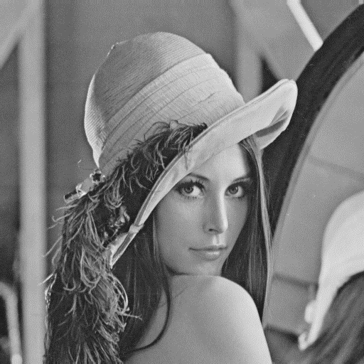

Frequency Domain

Code：

clc;clear all;close all;

input=imread('lena.bmp');

J=dct2(input);

figure

imshow(log(abs(J)),[])

colormap(gca,jet(64))

colorbar

Result：

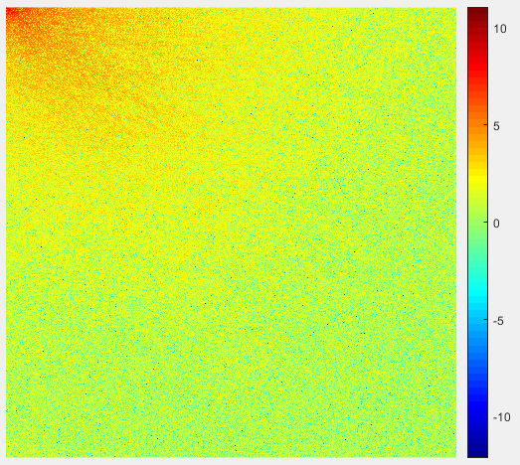

Spatial Domain

DCT Use formula：

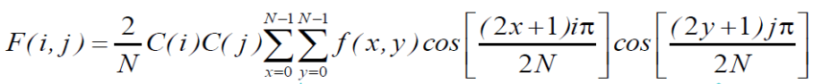

IDCT Use formula：

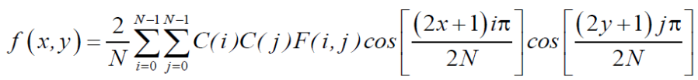

Code：

clc;clear all;close all;

n=2;

% a=[1 2 3 4;5 6 7 8;9 10 11 12;13 14 15 16];

a=imread('lena.bmp');

[A,B] = size(a);

%DCT

for i=1:2:A

for j=1:2:B

%00

Ans_DCT(i,j)=2/n*(2^-0.5)*(2^-0.5)*[a(i,j)*cos(0)*cos(0)+a(i,j+1)*cos(0)*cos(0)+a(i+1,j)*cos(0)*cos(0)+a(i+1,j+1)*cos(0)*cos(0)];

%01

Ans_DCT(i,j+1)=2/n*(2^-0.5)*1*[a(i,j)*cos(0)*cos(0.25*pi)+a(i,j+1)*cos(0)*cos(0.75*pi)+a(i+1,j)*cos(0)*cos(0.25*pi)+a(i+1,j+1)*cos(0)*cos(0.75*pi)];

%10

Ans_DCT(i+1,j)=2/n*1*(2^-0.5)*[a(i,j)*cos(0.25*pi)*cos(0)+a(i,j+1)*cos(0.25*pi)*cos(0)+a(i+1,j)*cos(0.75*pi)*cos(0)+a(i+1,j+1)*cos(0.75*pi)*cos(0)];

%11

Ans_DCT(i+1,j+1)=2/n*1*1*[a(i,j)*cos(0.25*pi)*cos(0.25*pi)+a(i,j+1)*cos(0.25*pi)*cos(0.75*pi)+a(i+1,j)*cos(0.75*pi)*cos(0.25*pi)+a(i+1,j+1)*cos(0.75*pi)*cos(0.75*pi)];

end

end

%IDCT

for i=1:2:A

for j=1:2:B

%00

Ans_IDCT(i,j)=2/n*[(2^-0.5)*(2^-0.5)*Ans_DCT(i,j)*cos(0)*cos(0)+(2^-0.5)*1*Ans_DCT(i,j+1)*cos(0)*cos(0.25*pi)+1*(2^-0.5)*Ans_DCT(i+1,j)*cos(0.25*pi)*cos(0)+1*1*Ans_DCT(i+1,j+1)*cos(0.25*pi)*cos(0.25*pi)];

%01

Ans_IDCT(i,j+1)=2/n*[(2^-0.5)*(2^-0.5)*Ans_DCT(i,j)*cos(0)*cos(0)+(2^-0.5)*1*Ans_DCT(i,j+1)*cos(0)*cos(0.75*pi)+1*(2^-0.5)*Ans_DCT(i+1,j)*cos(0.25*pi)*cos(0)+1*1*Ans_DCT(i+1,j+1)*cos(0.25*pi)*cos(0.75*pi)];

%10

Ans_IDCT(i+1,j)=2/n*[(2^-0.5)*(2^-0.5)*Ans_DCT(i,j)*cos(0)*cos(0)+(2^-0.5)*1*Ans_DCT(i,j+1)*cos(0)*cos(0.25*pi)+1*(2^-0.5)*Ans_DCT(i+1,j)*cos(0.75*pi)*cos(0)+1*1*Ans_DCT(i+1,j+1)*cos(0.75*pi)*cos(0.25*pi)];

%11

Ans_IDCT(i+1,j+1)=2/n*[(2^-0.5)*(2^-0.5)*Ans_DCT(i,j)*cos(0)*cos(0)+(2^-0.5)*1*Ans_DCT(i,j+1)*cos(0)*cos(0.75*pi)+1*(2^-0.5)*Ans_DCT(i+1,j)*cos(0.75*pi)*cos(0)+1*1*Ans_DCT(i+1,j+1)*cos(0.75*pi)*cos(0.75*pi)];

end

end

% Ans_DCT

imshow(Ans_IDCT)

imwrite(Ans_DCT,'lena_DCT.png')

imwrite(Ans_IDCT,'lena_IDCT.png')

Result：

lena_DCT.png

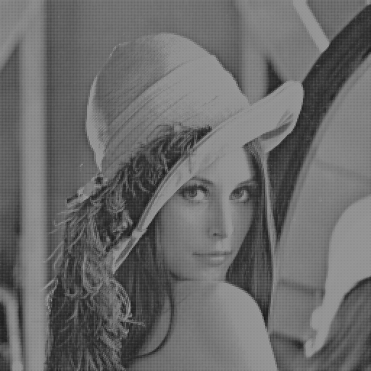

lena_IDCT.png

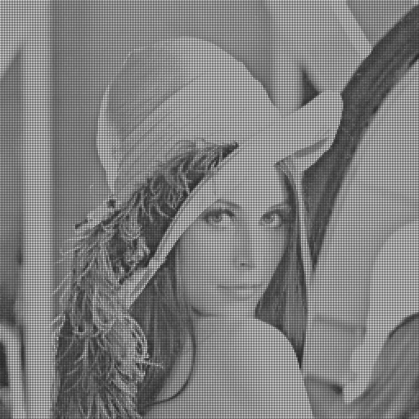

Additional Bonus: Fast DCT Algorithm

Spatial Domain

FDCT Use formula：

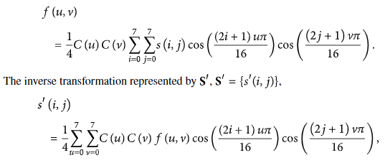

FIDCT Use formula：



Code：

clc;clear all;close all;

in_image=imread('lena.bmp');

% The array of variables needed for "u", "v", "i", "j" in the FDCT formula

cosines_DCT = [1.0000 1.0000 1.0000 1.0000 1.0000 1.0000 1.0000 1.0000

0.9808 0.8315 0.5556 0.1951 -0.1951 -0.5556 -0.8315 -0.9808

0.9239 0.3827 -0.3827 -0.9239 -0.9239 -0.3827 0.3827 0.9239

0.8315 -0.1951 -0.9808 -0.5556 0.5556 0.9808 0.1951 -0.8315

0.7071 -0.7071 -0.7071 0.7071 0.7071 -0.7071 -0.7071 0.7071

0.5556 -0.9808 0.1951 0.8315 -0.8315 -0.1951 0.9808 -0.5556

0.3827 -0.9239 0.9239 -0.3827 -0.3827 0.9239 -0.9239 0.3827

0.1951 -0.5556 0.8315 -0.9808 0.9808 -0.8315 0.5556 -0.1951];

alpha_DCT = [0.1250 0.1768 0.1768 0.1768 0.1768 0.1768 0.1768 0.1768

0.1768 0.2500 0.2500 0.2500 0.2500 0.2500 0.2500 0.2500

0.1768 0.2500 0.2500 0.2500 0.2500 0.2500 0.2500 0.2500

0.1768 0.2500 0.2500 0.2500 0.2500 0.2500 0.2500 0.2500

0.1768 0.2500 0.2500 0.2500 0.2500 0.2500 0.2500 0.2500

0.1768 0.2500 0.2500 0.2500 0.2500 0.2500 0.2500 0.2500

0.1768 0.2500 0.2500 0.2500 0.2500 0.2500 0.2500 0.2500

0.1768 0.2500 0.2500 0.2500 0.2500 0.2500 0.2500 0.2500];

% The array of variables needed for "u", "v", "i", "j" in the FIDCT formula

cosines_IDCT = [1.0000 1.0000 1.0000 1.0000 1.0000 1.0000 1.0000 1.0000

0.9808 0.8315 0.5556 0.1951 -0.1951 -0.5556 -0.8315 -0.9808

0.9239 0.3827 -0.3827 -0.9239 -0.9239 -0.3827 0.3827 0.9239

0.8315 -0.1951 -0.9808 -0.5556 0.5556 0.9808 0.1951 -0.8315

0.7071 -0.7071 -0.7071 0.7071 0.7071 -0.7071 -0.7071 0.7071

0.5556 -0.9808 0.1951 0.8315 -0.8315 -0.1951 0.9808 -0.5556

0.3827 -0.9239 0.9239 -0.3827 -0.3827 0.9239 -0.9239 0.3827

0.1951 -0.5556 0.8315 -0.9808 0.9808 -0.8315 0.5556 -0.1951];

alpha_IDCT = [0.1250 0.1768 0.1768 0.1768 0.1768 0.1768 0.1768 0.1768

0.1768 0.2500 0.2500 0.2500 0.2500 0.2500 0.2500 0.2500

0.1768 0.2500 0.2500 0.2500 0.2500 0.2500 0.2500 0.2500

0.1768 0.2500 0.2500 0.2500 0.2500 0.2500 0.2500 0.2500

0.1768 0.2500 0.2500 0.2500 0.2500 0.2500 0.2500 0.2500

0.1768 0.2500 0.2500 0.2500 0.2500 0.2500 0.2500 0.2500

0.1768 0.2500 0.2500 0.2500 0.2500 0.2500 0.2500 0.2500

0.1768 0.2500 0.2500 0.2500 0.2500 0.2500 0.2500 0.2500];

O_DCT = double(zeros(8,8));

O_IDCT = double(zeros(8,8));

[A,B] = size(in_image);

for i=1:8:A

for j=1:8:B

% Create an 8*8 array with the input image divided into 8*8 values

I=[in_image(i,j) in_image(i,j+1) in_image(i,j+2) in_image(i,j+3) in_image(i,j+4) in_image(i,5) in_image(i,6) in_image(i,7);

in_image(i+1,j) in_image(i+1,j+1) in_image(i+1,j+2) in_image(i+1,j+3) in_image(i+1,j+4) in_image(i+1,5) in_image(i+1,6) in_image(i+1,7);

in_image(i+2,j) in_image(i+2,j+1) in_image(i+2,j+2) in_image(i+2,j+3) in_image(i+2,j+4) in_image(i+2,5) in_image(i+2,6) in_image(i+2,7);

in_image(i+3,j) in_image(i+3,j+1) in_image(i+3,j+2) in_image(i+3,j+3) in_image(i+3,j+4) in_image(i+3,5) in_image(i+3,6) in_image(i+3,7);

in_image(i+4,j) in_image(i+4,j+1) in_image(i+4,j+2) in_image(i+4,j+3) in_image(i+4,j+4) in_image(i+4,5) in_image(i+4,6) in_image(i+1,7);

in_image(i+5,j) in_image(i+5,j+1) in_image(i+5,j+2) in_image(i+5,j+3) in_image(i+5,j+4) in_image(i+5,5) in_image(i+5,6) in_image(i+1,7);

in_image(i+6,j) in_image(i+6,j+1) in_image(i+6,j+2) in_image(i+6,j+3) in_image(i+6,j+4) in_image(i+6,5) in_image(i+6,6) in_image(i+6,7);

in_image(i+7,j) in_image(i+7,j+1) in_image(i+7,j+2) in_image(i+7,j+3) in_image(i+7,j+4) in_image(i+7,5) in_image(i+7,6) in_image(i+7,7)];

% Start calculating FDCT, input is I array, output is O_DCT array

for p = 1 : 8

for q = 1 : 8

s_DCT = double(0);

for m = 1 : 8

for n = 1 : 8

% Make the sigma part behind the formula

s_DCT = s_DCT + (double(I(m,n)) * cosines_DCT(p,m) * cosines_DCT(q,n));

end

end

% Do the multiplication of C(u)C(v) in front of the formula

O_DCT(p,q) = alpha_DCT(p,q) * s_DCT;

end

end

% Start calculating FIDCT, input is O_DCT array, output is O_IDCT array

for m = 1 : 8

for n = 1 : 8

s_IDCT = double(0);

for p = 1 : 8

for q = 1 : 8

% Do the sigma and multiplication part of the formula

s_IDCT = s_IDCT + (alpha_IDCT(p,q) * double(O_DCT(p,q)) * cosines_IDCT(p,m) * cosines_IDCT(q,n));

end

end

% Store results

O_IDCT(m,n) = s_IDCT;

end

end

% Combine the results of FIDCT conversion from multiple 8*8 arrays --> a whole image

for aa=1:1:8

for bb=1:1:8

Ans_FIDCT(i+aa-1,j+bb-1)=uint8(O_IDCT(aa,bb));

end

end

end

end

imshow(Ans_FIDCT)

imwrite(Ans_FIDCT,'lena_FIDCT.png')

Result：

lena_FDCT.png



lena_FIDCT.png

